**EXSUM**

**Finance II Business Case Analysis**

## Method of research/Model: Business Case Analysis Guide and PCMH Model

**Domain:** Health Resource Allocation/Performance Measurement and Improvement

**Problem:** Can North Central Federal Clinic recapture Prime, primary purchased care? What is the cost benefit analysis on recapturing $421,994 of network enrolled prime, primary purchased care?

**Overview**

The analysis measured three courses of action (COA).

**COA 1: Status Quo**. Network enrollees remain on the network. This course of action evaluates business as usual. No additional personnel are hired. The three additional exam rooms remain unused by DOD personnel.

**COA 2: Network Enrollees Return to NCFC.** Tricare Prime Network enrollees are requested to enroll into NCFC. No additional staff required for this course of action. The three additional exam rooms remain unused by DOD personnel.

**COA 3: Network Enrollees Return to NCFC and Increase in Medical Staff to Accommodate 100% Recapture.** Tricare Prime Network enrollees are requested to enroll into NCFC. Decrease current panel size to PCMH and business plan standards and hire additional personnel. Utilize two exams that are currently unoccupied for patient care.

**Scope:**

* + Projected Analysis period: FY 15 - FY 19
  + Historical Data: FY13 - FY14

**Assumptions**:

1. The recapture potential is 100% of currently assigned network enrollees. The sensitivity analysis will predict the impact of changes in volume.
2. Based on growth projections over the past five years, the enrollment growth will not substantially grow or decrease between FY14 and FY19.
3. Ancillary services under VA control can accommodate increase in enrollment.
4. Patient catchment area is a 20-mile radius around NCFC.
5. VA and DOD memorandum of agreement will not drastically change in the future.

**COA Comparison**

**Net Present Value (NPV)**The NPV is a profitability measure that uses the discounted cash flow technique. The project team assigned the discount rate of 2.2% to this BCA as suggested by OMB Circular #A-94 for FY 2015.

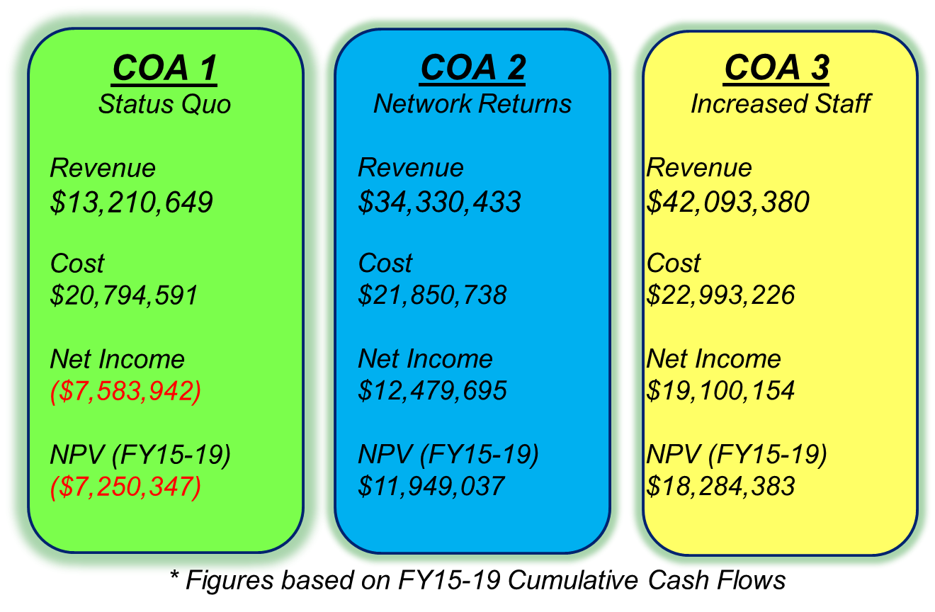

**Conclusions**

* Given the current staffing model the NCFC has the capacity to accommodate approximately 925 Network Prime Enrollees



* To recapture the entire $421,994 of network enrolled prime, primary purchased care the NCFC would have to increase its current staffing model

**Recommendations**

**Combination of Course of Action 2 and 3**

* Optimize current capacity by returning network enrollees to the NCFC
* If projected number of network enrollees return, increase staff to meet demand

**Lessons Learned**

Sensitivity analysis allows for variances in your findings based off of changes in your assumptions.