ACHE Competencies Assessment Tool
MAJ Oscar Ochoa
HCA5342 Health Applications in Networking & Telecommunications
Army-Baylor Masters of Health Administration

In today’s healthcare environment executives must have the ability to manage their organizations. The healthcare environment is becoming more and more complex and organizations try to find way to stop the ever increasing cost of medical care and still make a profit for their organizations. Healthcare executives are expected to show a certain level of competency in the core requirements that their jobs entail. These competencies must be measureable and defined in a preset list of requirements and benchmarks. Evidence based medicine is calling for results and healthcare executives must produce these results. The follow is a synopsis of the ACHE Competencies Assessment Tool and the ACHE Board of Governors (BOG) exam. This review focuses on the need for competency assessment guidelines for healthcare administrators. These competencies are derived from the Healthcare Leadership Alliance Competency Directory.
The ACHE is recognized as one of the premier healthcare executive administration organizations. The ACHE Competencies Assessment Tool is a self-awareness tool designed to help individuals identify areas of weaknesses and strengths. If used appropriately, the tool acts as a guide for career planning and gives individuals goals to strive for to attain certain level of competencies in the five core domains. The domains are: communication and relationship management, leadership, professionalism, knowledge of the healthcare environment, and business skills/knowledge (American College of Healthcare Executives, 2014). Each domain has sub-elements that allow individuals to refine their skills as healthcare administrators.
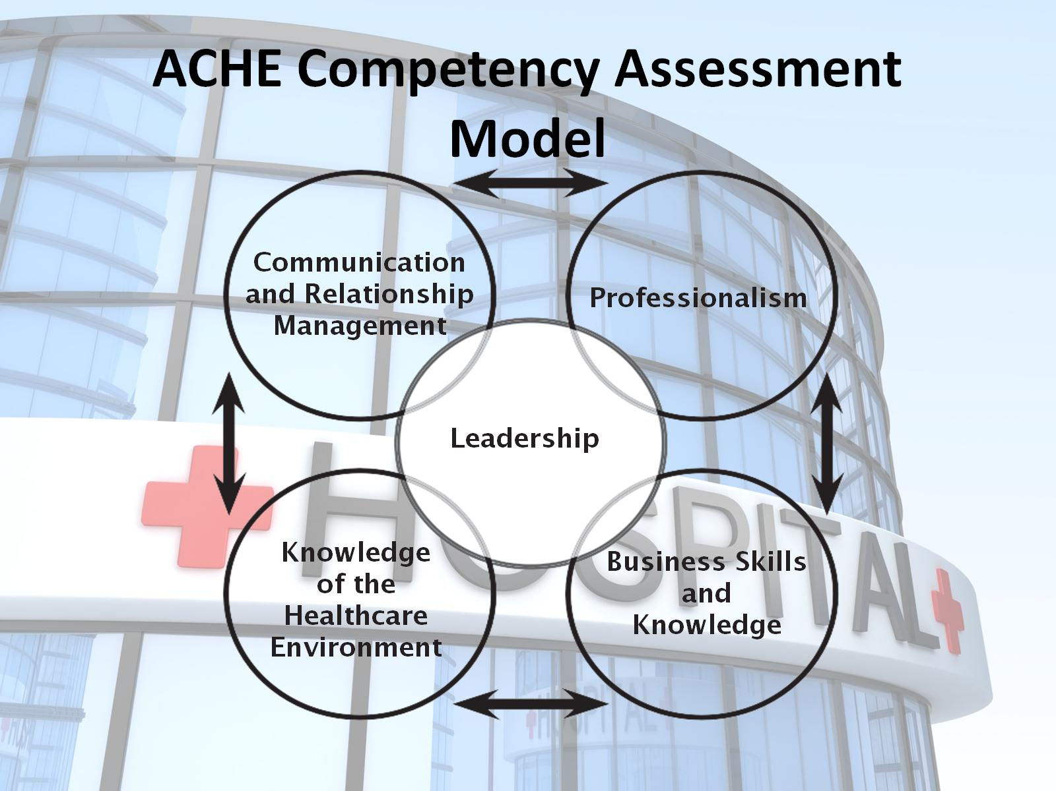
The first area of that the ACHE Competencies Assessment Tool focuses on is communication and relationship management. Healthcare executives must have the ability to communicate clearly and concisely with customers who are internal and external to their organization. They must also be able to facilitate and maintain these relationships with individuals or groups. These skills include relationship management, communication skills, and facilitation and negotiation. For a executive to be competent at relationship management they should have skills such as the ability to build collaborative relationships, developing and maintaining medical staff relationships, and the ability to provide internal customer service. This area covers eight subsets of competencies. In the communications skills area executives should be able to have good public relations skills, sensitivity to correct behavior when it comes to things such as culture, and the ability to communicate the mission and vision of the organization. Communications skill has nine subset competencies. Facilitation and Negotiation has seven subset competencies to include things such as, team building techniques, labor relations strategies, and building effective physician and healthcare administrator teams.
Leadership is the second major competency in this model and contains four subsets. Leadership skills and Behavior is one of the subsets and includes eleven more detailed subcomponents. Some of these include the development of external relationships, fostering and environment of mutual trust, and the advocating and participating in healthcare policy initiatives. The second subset is Organizational Climate and Culture. This includes things such and creating an organizational climate that encourages teamwork and knowledge of own and others’ cultural norms. There are four subcomponents in this subset. The third subset is Communicating Vision; this includes things such as the ability to create an organizational climate that facilitates individual motivation and the ability to encourage a high level of commitment to the purpose and values of the organization. There are five subcomponents in this subset. The last subset of this competency is Managing change, this encompasses six subcomponents.
The third major competency in this model is professionalism. This competency contains three subsets. The first of which is Personal and Professional Accountability. This encompasses things such as professional standards and codes of ethical behavior, organizational business and personal ethics, and consequences of unethical actions there are eleven subcomponents to this subset. Contributions to the ones community and profession are another subset which includes this such as mentorship, advising, and coaching as well as serve as an ethical guide for the organization. There are seven subcomponents to this subset. The last subset covered under the professionalism competency is professional development and lifelong learning. It is paramount the executives continue to grow as leaders. There are eight subcomponents to this subset.
Knowledge of the healthcare environment is the fourth competency of the five in the ACHE competency model. This covers four subcomponents. These are healthcare systems and organizations, healthcare personnel, the patient’s perspective, the community and the environment. The last of the five subsets is business skills and knowledge. This is the broadest of all five competencies and entails eight subsets and one hundred and seventy-five subcomponents. This is by far the broadest and most knowledge intensive competency that healthcare executives must have mastery of in the ACHE competency model.
Once healthcare administrators have demonstrated mastery of their knowledge in those ACHE competencies they may apply to get credentialed as a fellow by passing the Board of Governors (BOG) exam (American College of Healthcare Executives, 2014). The guidance in the ACHE Competencies Assessment Tool allows healthcare administrators to focus their efforts in the appropriate competencies to be successful as healthcare leaders and executives. This tool can be used through a healthcare executive’s career to ensure that the executive stays current in the healthcare administration field. Healthcare executive leaders can also use this to guide those employees that they mentor. All healthcare executives need to demonstrate a certain level of competency to ensure they are leading organizations in the right direction in the healthcare world. This tool ensures those competencies levels are achieved.

Works Cited
American College of Healthcare Executives. (2014). ACHE Healthcare Executive. Competency Assessment Tool 2015. Chicago: Healthcare Leadership Alliance and the American College of Healthcare Executives.
American College of Healthcare Executives. (2014, April 10). American College of Healthcare Executives . Retrieved from Credentialing: https://www.ache.org/apps/recertification.cfm

